# 8. Code:

## 8.1 Amazon OA:

## <https://aonecode.com/amazon-online-assessment>

### 8.1.1 Flip neighbors (Demo version):

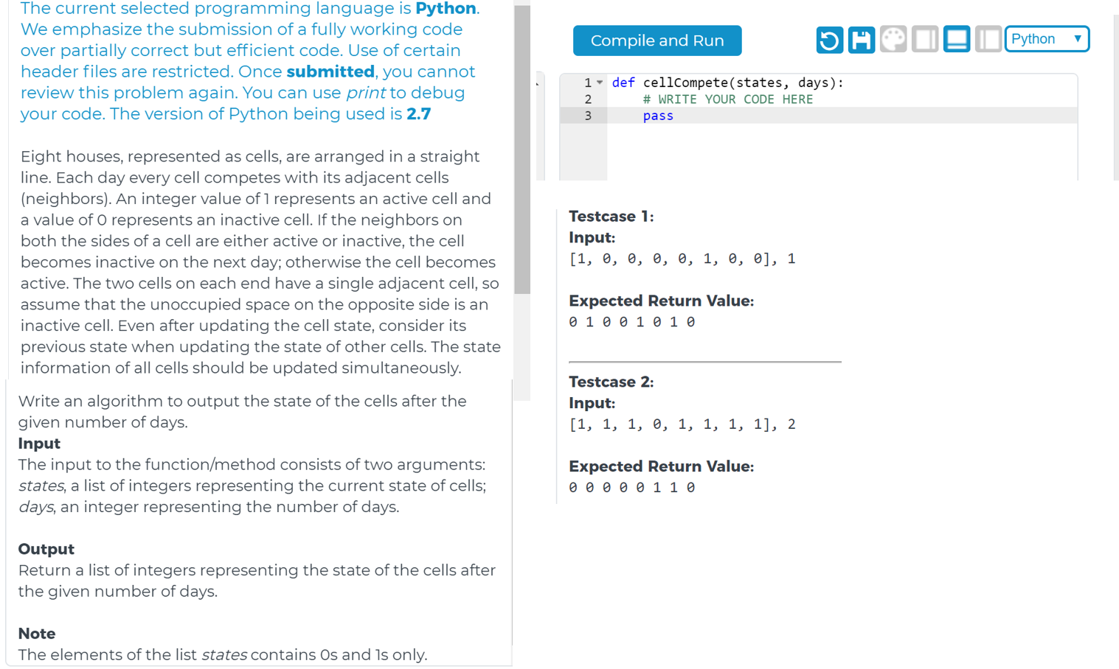

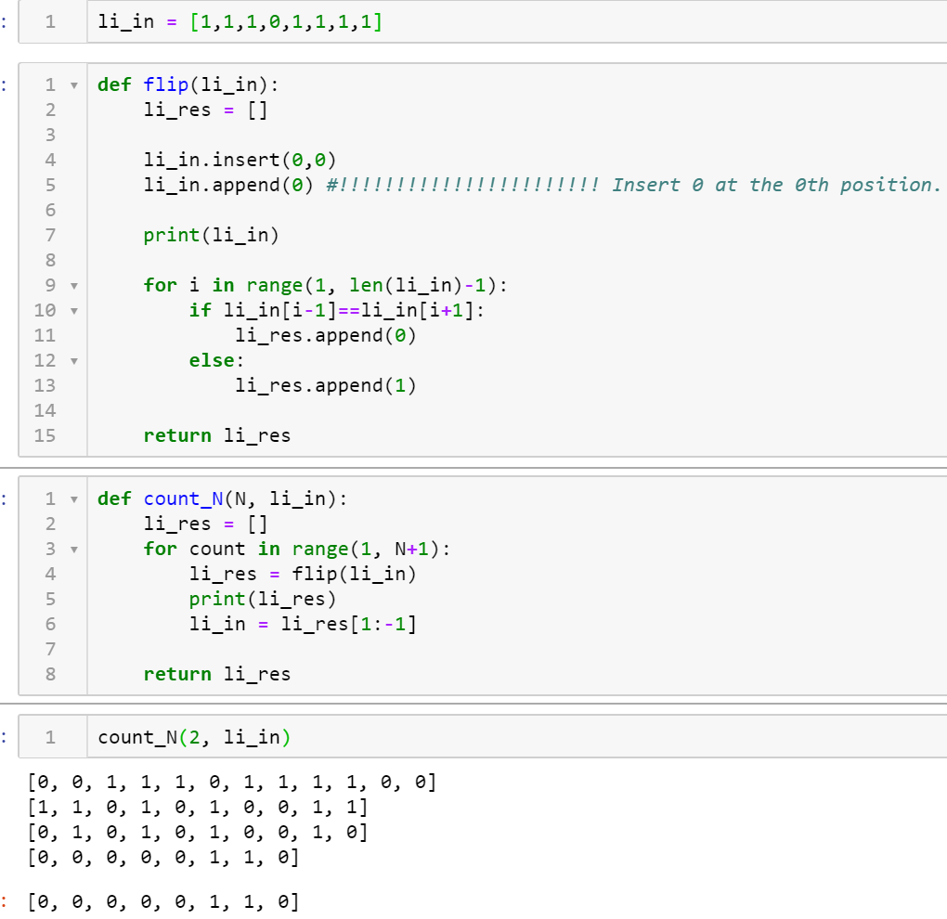

### 8.1.2 Greatest Common Divisor (GCD):

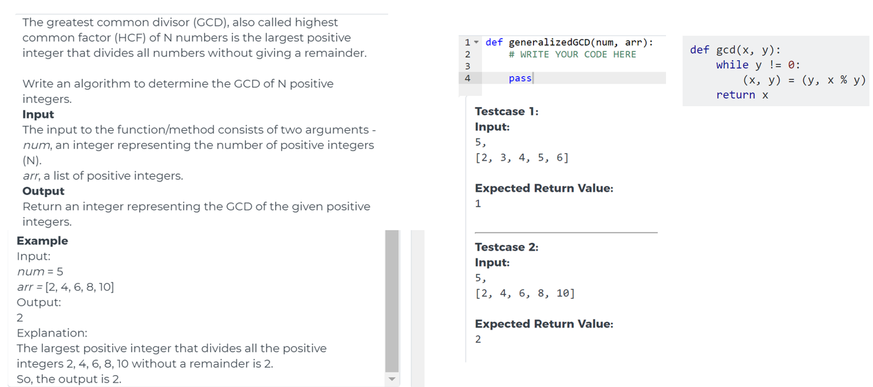

### 8.1.3 Max value match sum of [index, memory]:

两个list，每个都含了一系列的（index，内存），给你个总内存数K，要求两个list里的内存相加<=k,

return 最大‍‌‌‍‌‍‌‌‍‍‌‌‍‌‍‌‌‍‍组合的index（如果有多个相同的话，都要return）.

比如： input的容量k是5，两个list是[[1,4],[2,1],[3,2]]和[[1,2]]，   
因为第一个list里[3,2]的2和第二个list里[1,2]的2加起来是4(<=5)是最接近k的组合，

所以输出他们的index: [[3,1]]. 如果有多个相同的结果，那就都要return.

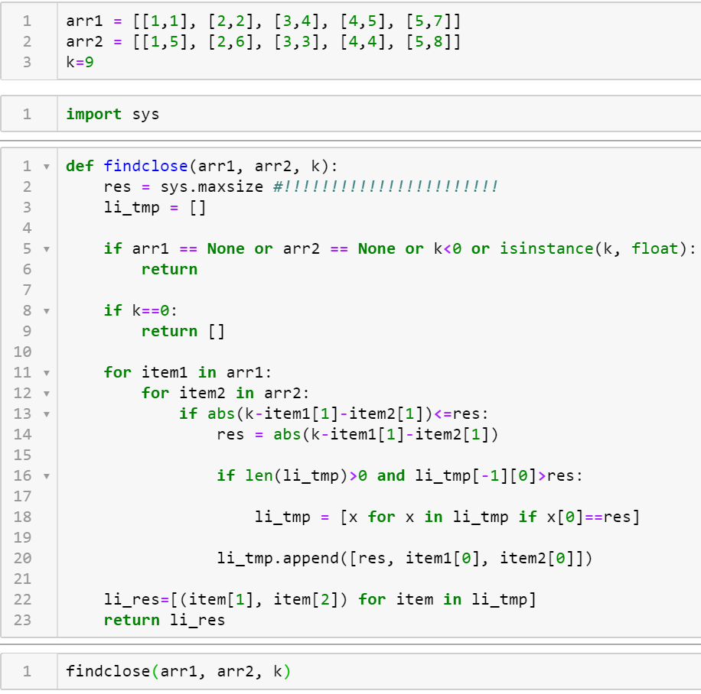



### 8.1.4 Word Frequency:

给一个string，是一篇小说内容，比如"Jimmy has an apple, it is on the table" 再给一个exclude word list，比如 "an" "a" "is" "the"，让你给出这个string里出现频率最高的单词

(优先队列搞定，注意输入为0的edge case)

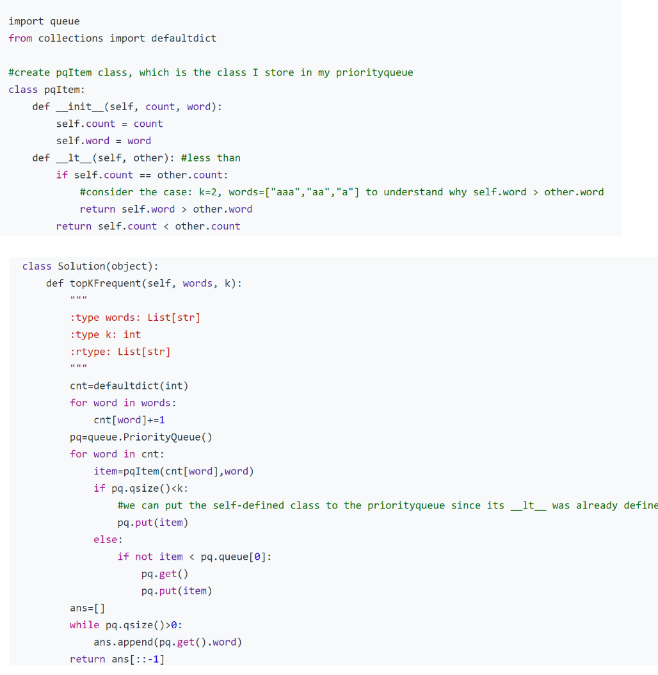

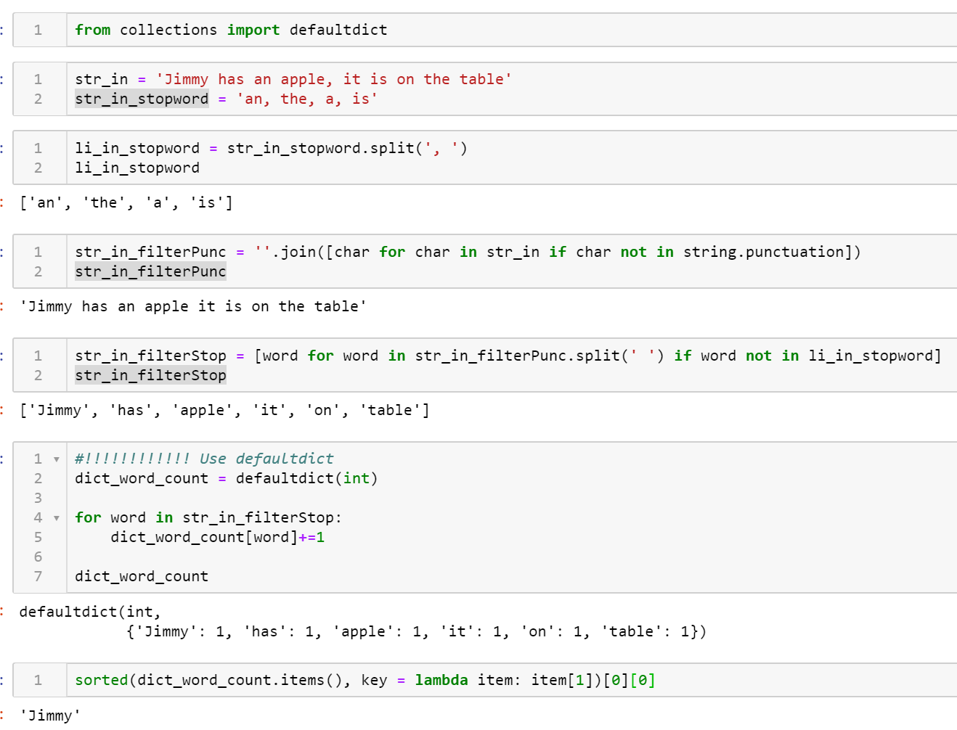

### 8.1.5 Log File:

第二题，给你一个log file，List<String>，每个元素代表log file一行，在每个元素里面，有substring，他们用空格分开，比如"a1ws efg7 i90s", String里面只有字母和数字，第一个substring是id，依据id后面的substring给log file排序，字母在top。  
比如input是  
["fhie 1df8 sfds", "fdsf 2def sees", "efe2 br9o fjsd", “asd1 awer jik9"]  
‍‌‌‍‌‍‌‌‍‍‌‌‍‌‍‌‌‍‍  
  
output是：  
[“asd1 awer jik9", "efe2 br9o fjsd", "fhie 1df8 sfds", "fdsf 2def sees"]

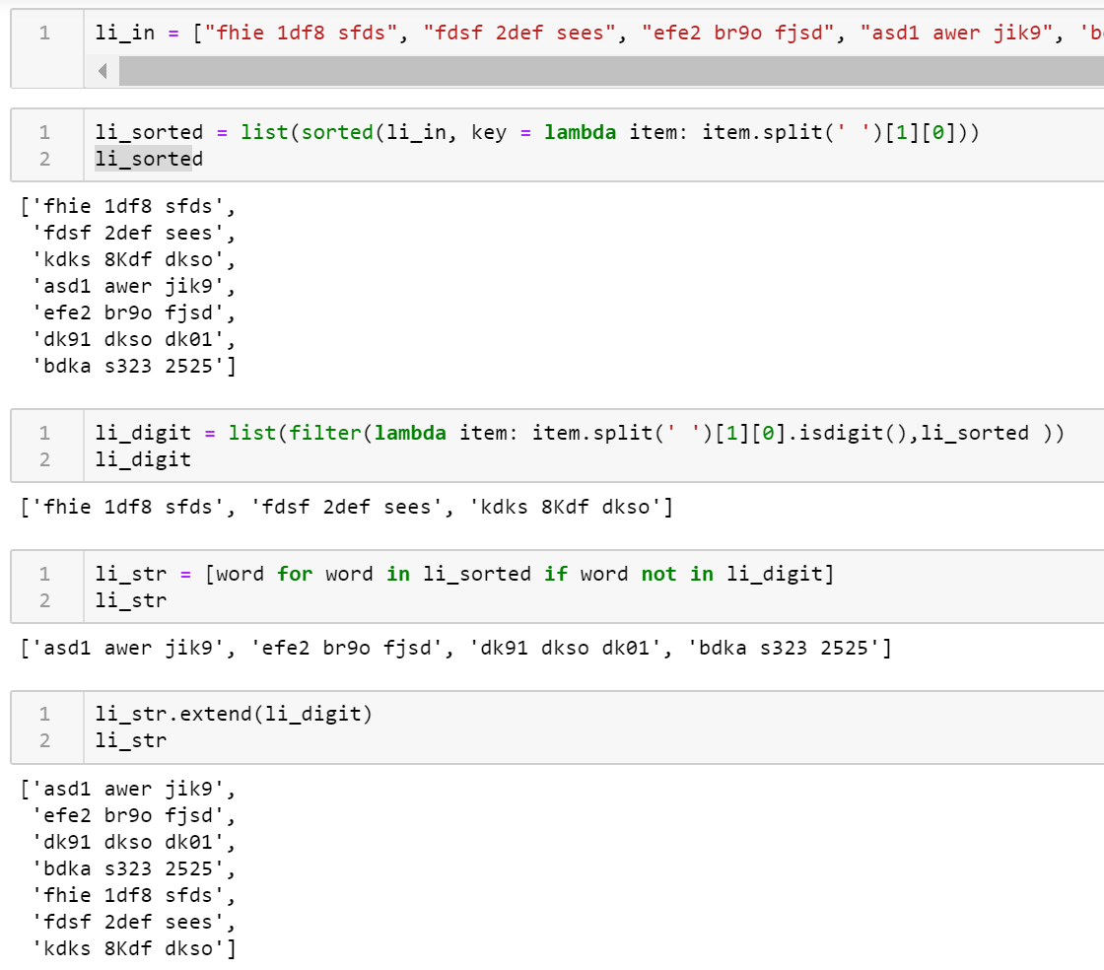

### 8.1.6 (priority queue)Nearest Steak store:

<https://blog.csdn.net/roufoo/article/details/82998643>

离原点最近的前k个牛排店，排序2 sum，不超过target且尽可能大，要求输出所有pair，考虑到重复直接平方暴力  
8.1.7 (BFS) Shortest path:

What is BFS? <https://eddmann.com/posts/depth-first-search-and-breadth-first-search-in-python/>

* DefaultDict: store the graph;
* Queue: Save the Nodes and mark the visited nodes
* 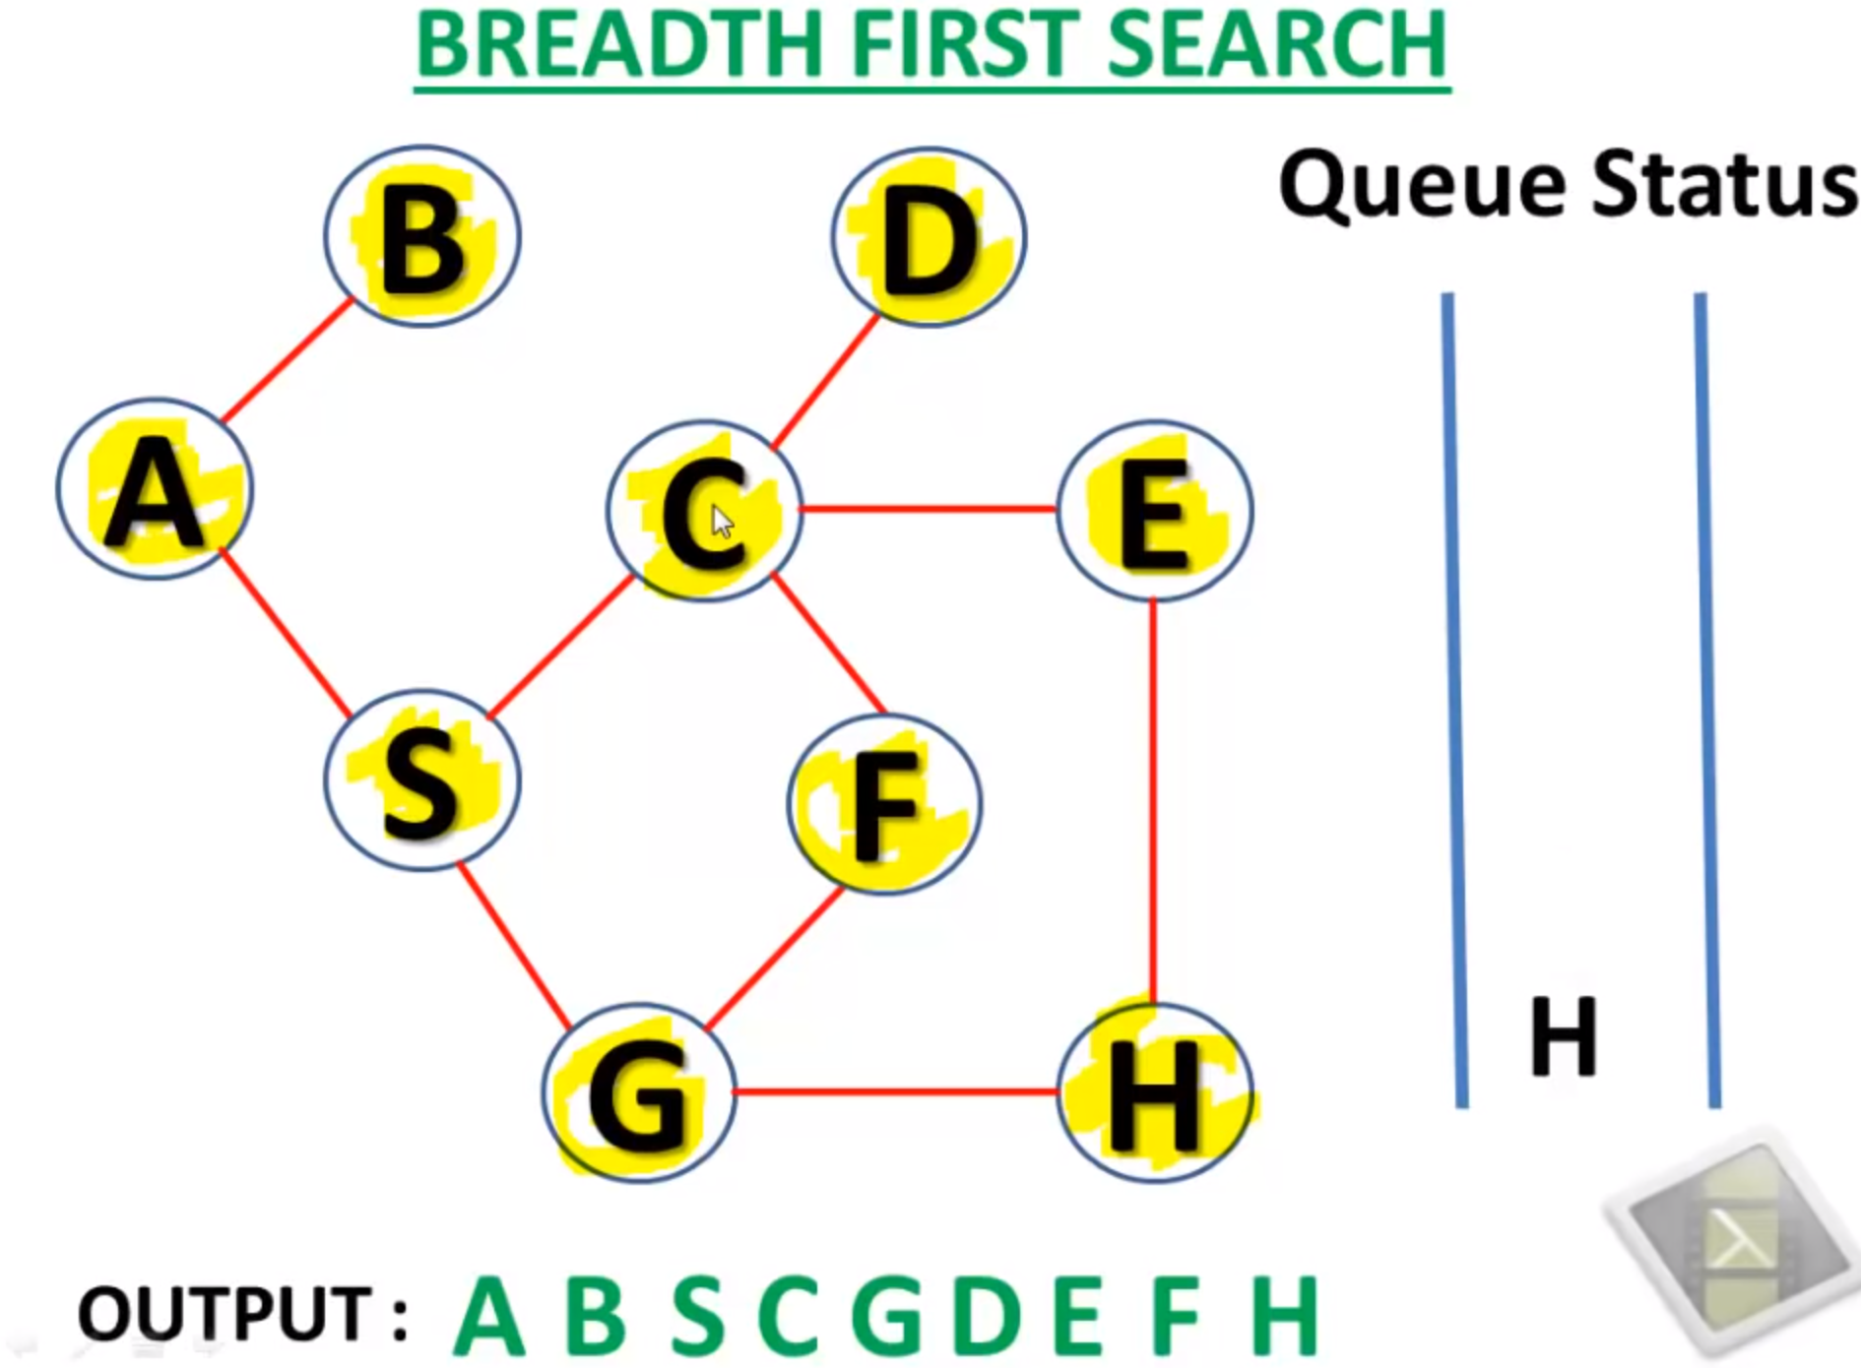

从[0,0] 出发，0表示点不能去，1‍‌‌‍‌‍‌‌‍‍‌‌‍‌‍‌‌‍‍ 表示能去，9为终点，找去目标点的最短路径(从（0,0）到出口的最少steps)，如果找不到path就返回-1

input是list<list>

DFS-Depth First Search:

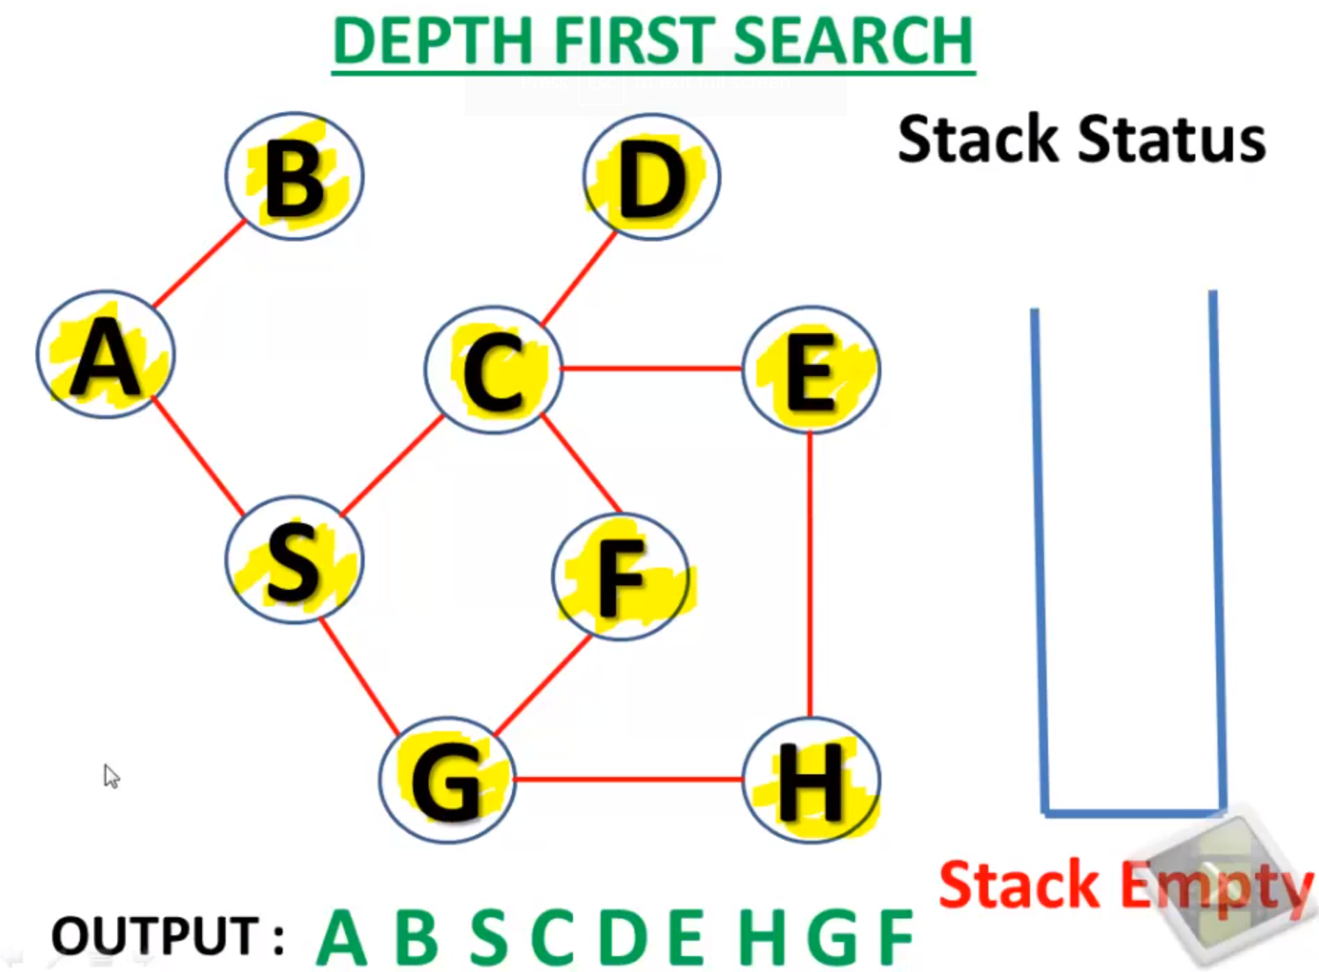

### 8.1.8 Count number of substrings with exactly k distinct characters:

<https://www.geeksforgeeks.org/count-number-of-substrings-with-exactly-k-distinct-characters/>

<https://leetcode.com/problems/longest-substring-with-at-least-k-repeating-characters/>

Input: abc, k = 2  
Output: 2  
Possible substrings are {"ab", "bc"}

Input: aba, k = 2  
Output: 3  
Possible substrings are {"ab", "ba", "aba"}

Input: aa, k = 1  
Output: 3  
Possible substrings are {"a", "a", "aa"}

Method I:

The problem can be solved in O(n*n). Idea is to maintain a hash table while generating substring and checking the number of unique characters using that hash table.  
The implementation below assume that the input string contains only characters from ‘a’ to ‘z’.

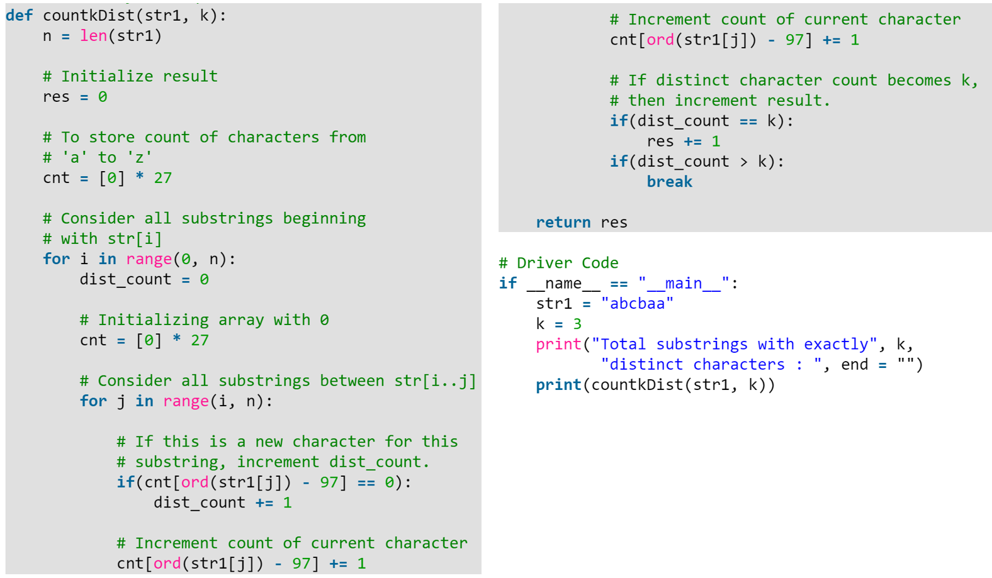

Method II:

A recursive solution.  
**Stopping condition**: if length of the current string is less than k, return 0.  
Count the number of appearance for each character with a dict.

If all the character has number of appearance no smaller than k, return the length of this string,

otherwise, split the string into substring by the characters with appearance less than k and recursively call the function on each of the substring, return the maximum returning value among those calls.

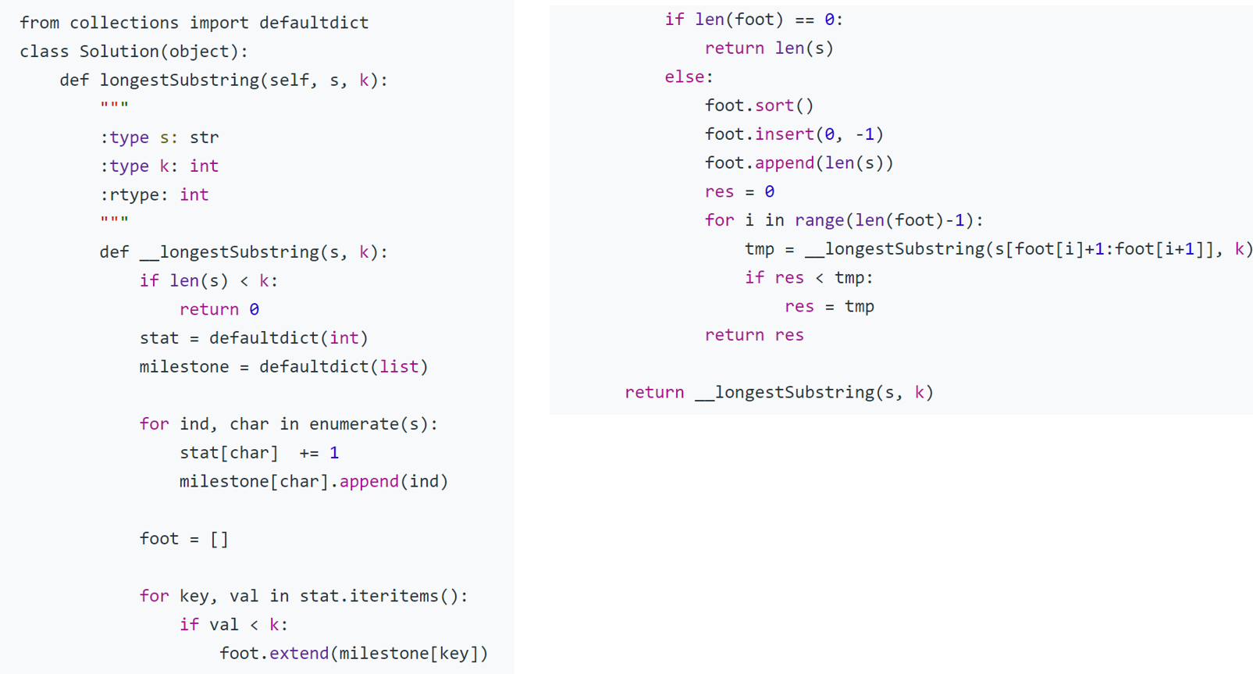

### 8.1.9 Maze II:

### <https://leetcode.com/articles/the-maze-ii/?page=2>

### 8.1.10 Closest sum:

出发点m个，各自包含一个里程数，到达点n个，也是各自包含一个里程数。给一个最大可以到达的里程数 num。求出最接近 num 并且不大于他的一组出发到达。

### 8.1.11 Creat BST & node distance:

给定数组 求建bst, 并求指定两个node之间的距离( 可能不存在在树里头)

8.1.13 (Heap) Nearest points:

一组destination坐标，求最近的x个：

一组饭馆坐标，输入k，返回k个里客户（[0,0]）最近的饭馆坐标，返回结果由近到远排序 解法（heap）

<https://leetcode.com/articles/k-closest-points-to-origin/>

Method 1:

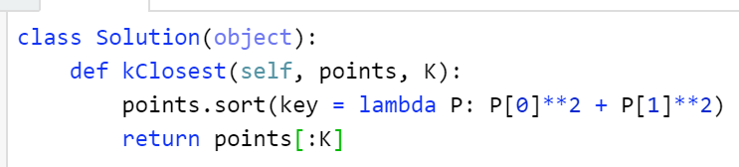

Method 2:

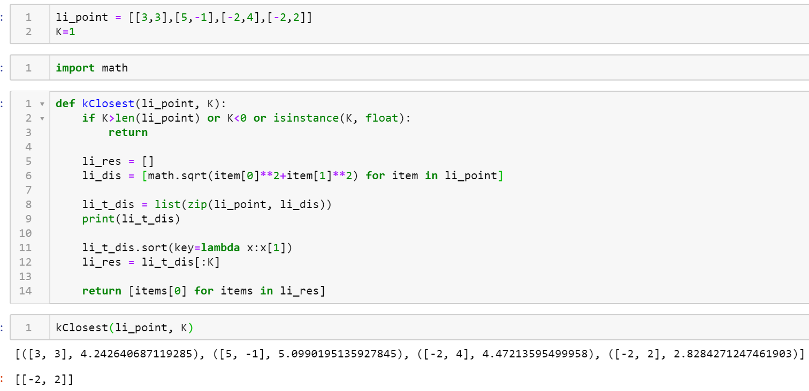

### 8.1.14 (???Hash): Flight Film recommendation:

<https://leetcode.com/discuss/interview-question/313719/amazon-online-assessment-2019-two-sum-closest>

**Question:**  
You are on a flight and wanna watch two movies during this flight.  
You are given List<Integer> movieDurations which includes all the movie durations.  
You are also given the duration of the flight which is d in minutes.  
Now, you need to pick two movies and the total duration of the two movies is less than or equal to (d - 30min).

Find the pair of movies with the longest total duration and return they indexes. If multiple found, return the pair with **the longest movie**.

**Example 1:**

Input: movieDurations = [90, 85, 75, 60, 120, 150, 125], d = 250

Output: [0, 6]

Explanation: movieDurations[0] + movieDurations[6] = 90 + 125 = 215 is the maximum number within 220 (250min - 30min)

Answer:  
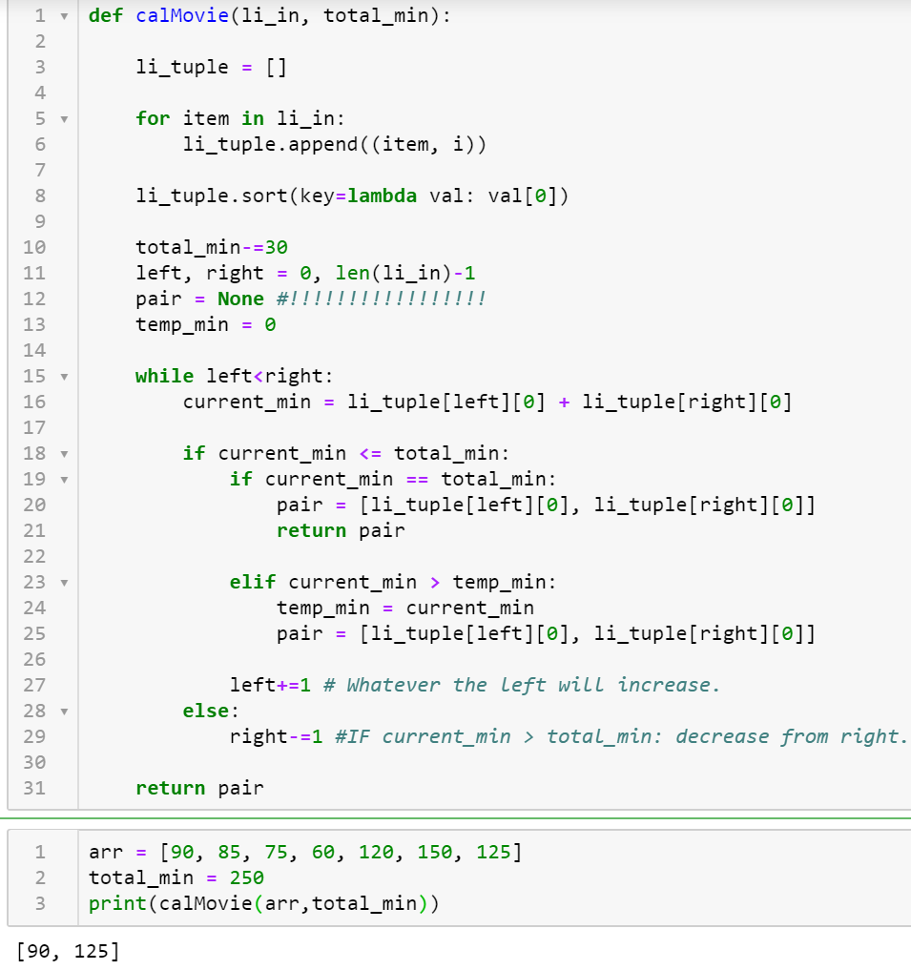  
8.1.15 (Tree).

树的问题，每个结点有一个value，表示这个结点有多少代码行数被改动了，然后子树就是他依赖的结点，要去找一个结点使得 它当前结点改动的代码行数+他依赖（子树）的所有结点的代码行数 的平均最大。

### 8.1.16

类似：<https://leetcode.com/problems/dungeon-game/discuss/379523/Python-DP-two-solutions-with-comments>

一个小哥去爬山，给一个矩阵，要从左上角爬到右下角，每一步只能往右往下走。矩阵的每一个值是这一点的海拔。显然有很多条路可以走，每一条路都有一个经过的海拔最低值，求所有路径的海拔最低值的最大值。‍‌‌‍‌‍‌‌‍‍‌‌‍‌‍‌‌‍‍  
比如：  
5 4 5  
1 3 6  
有三条路可以走：5 1 3 6，5 4 3 6，5 4 5 6。三条路的最小值分别是1,3,4。求的就是这三个数的最大值，也就是4。我直接暴力写的

### 8.1.17: MaximumMinimumPath

[8, 4, 7]  
[6, 5, 9]  
有3条path：  
8-4-7-9 min: 4  
8-4-5-9 ‍‌‌‍‌‍‌‌‍‍‌‌‍‌‍‌‌‍‍min: 4  
8-6-5-9 min: 5  
return: 5  
  
DFS，用全局变量记录max和min

### 8.1.18 Debugging:

<https://www.evernote.com/client/snv?noteGuid=d0047552-4cff-4c29-b305-b8aa2d33f364&noteKey=636f07d57c2eb3ea&sn=https%3A%2F%2Fwww.evernote.com%2Fshard%2Fs683%2Fsh%2Fd0047552-4cff-4c29-b305-b8aa2d33f364%2F636f07d57c2eb3ea>

### 8.1.20 Search a 2d Matrix:

<https://leetcode.com/problems/search-a-2d-matrix-ii/>

8.1.21 critical connections:

<https://www.geeksforgeeks.org/bridge-in-a-graph/>

找连通图(2d array)里的所有bridge(critical connections), 使得这个graph变成两个disconnected parts.

8.1.22: Subset:

<https://leetcode.com/problems/subsets/>

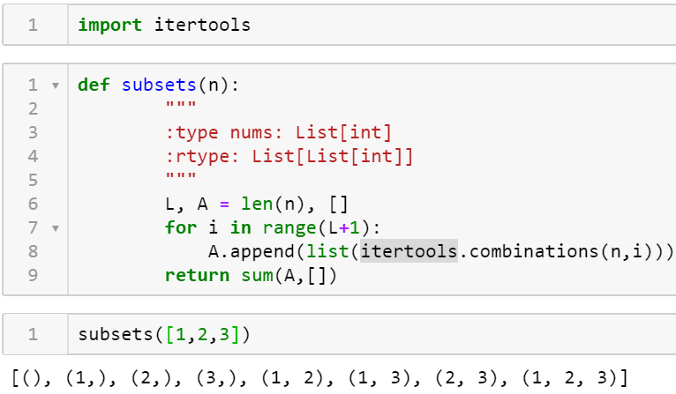 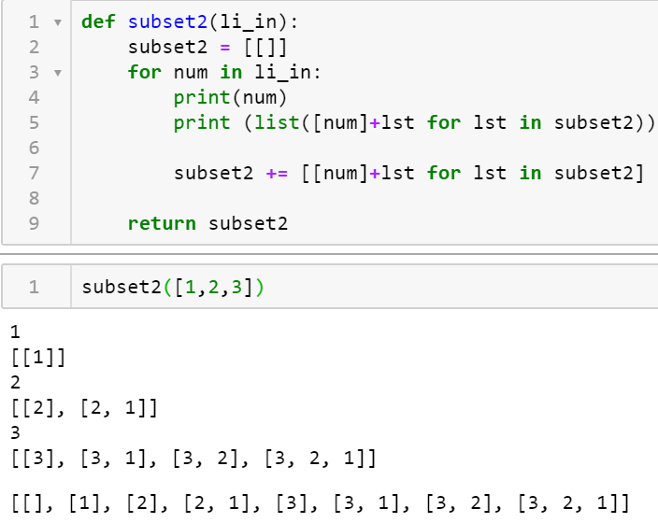

8.1.22: Treasure Island:

<https://leetcode.com/discuss/interview-question/347457>

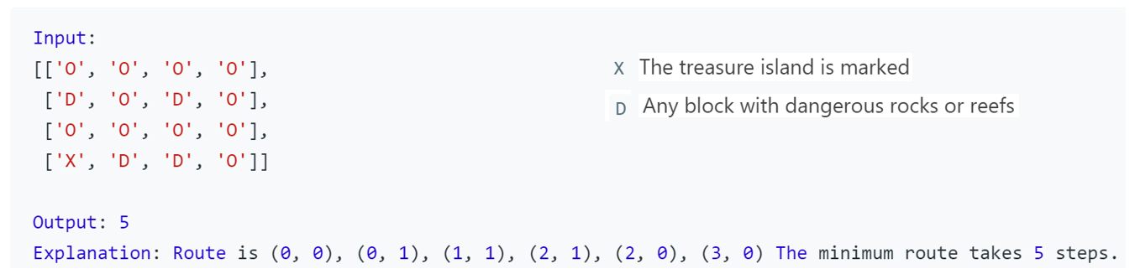

Answer:

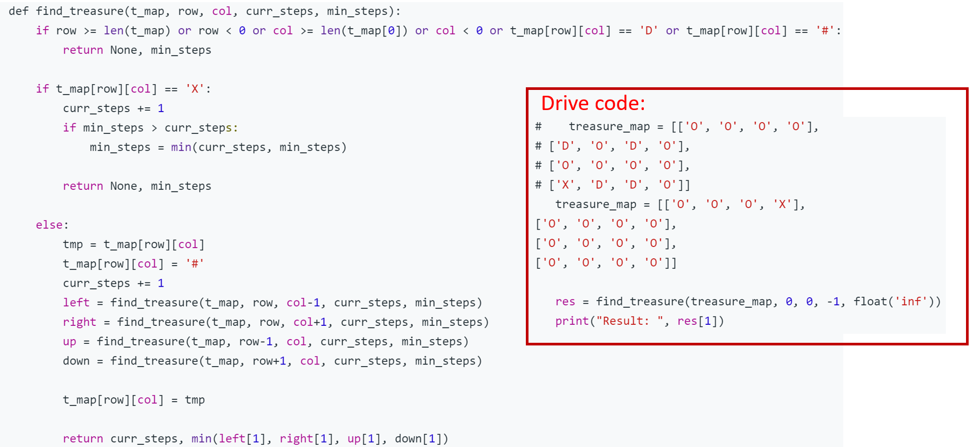

Method 2:

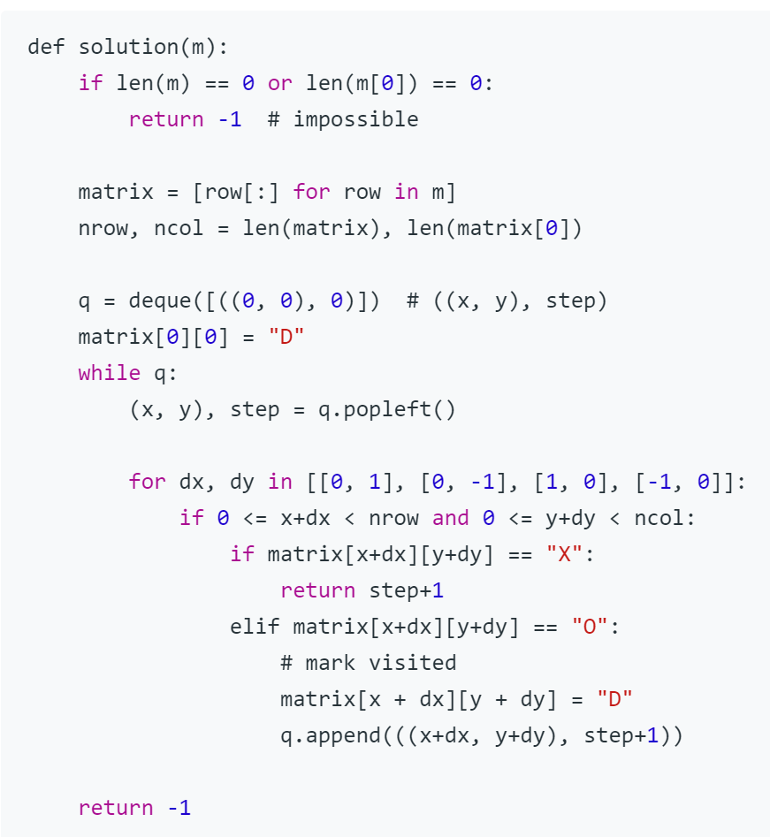

### 8.1.21 Favorite Genres

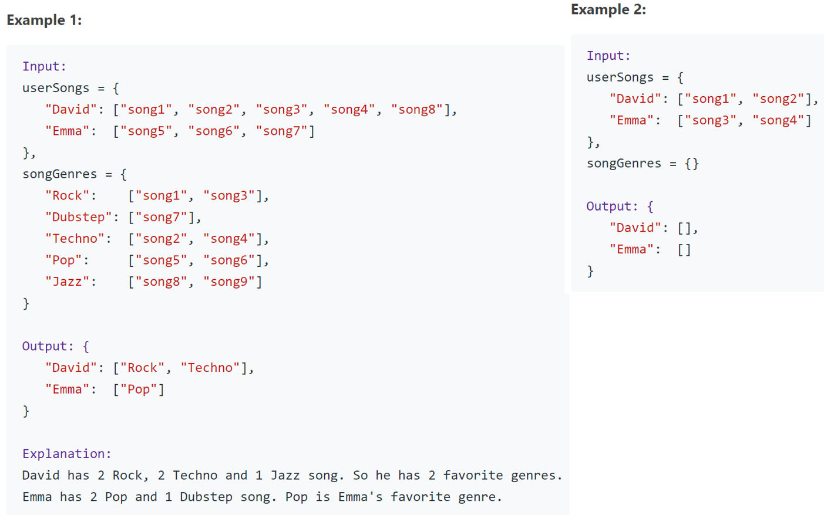

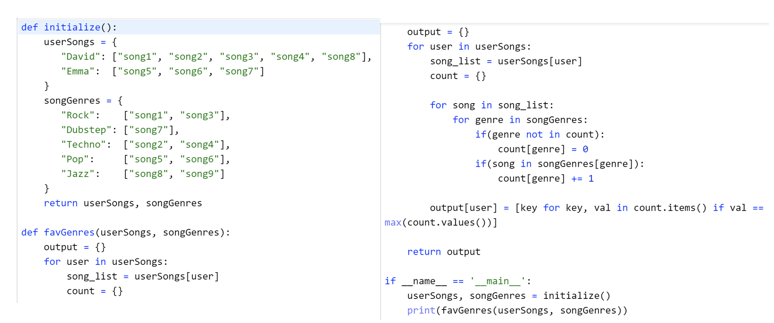

### 8.1.22 Two Sum - Unique Pairs

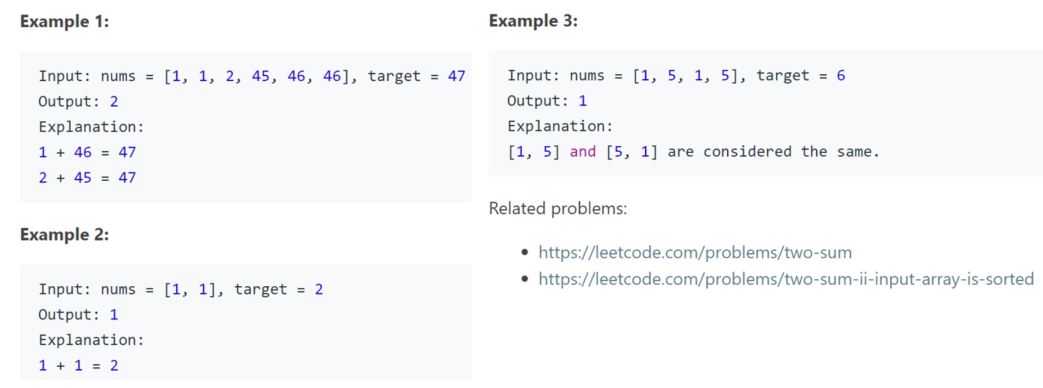

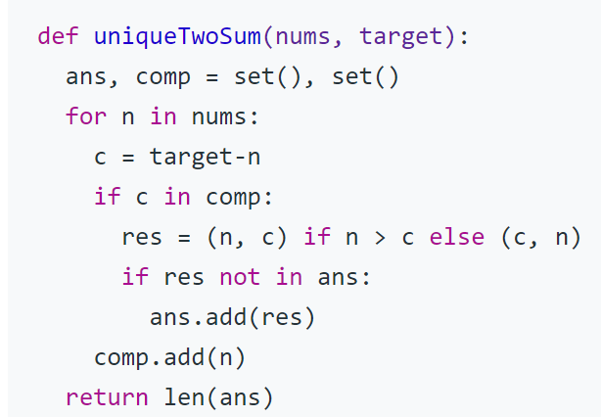

### 8.1.23 customer reviews:

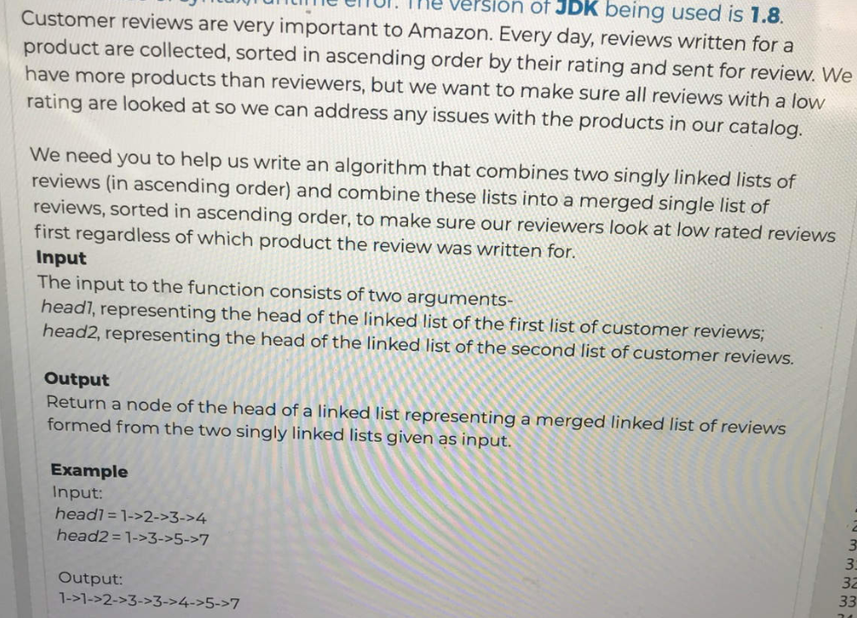

8.1.24 subtree of decision tree

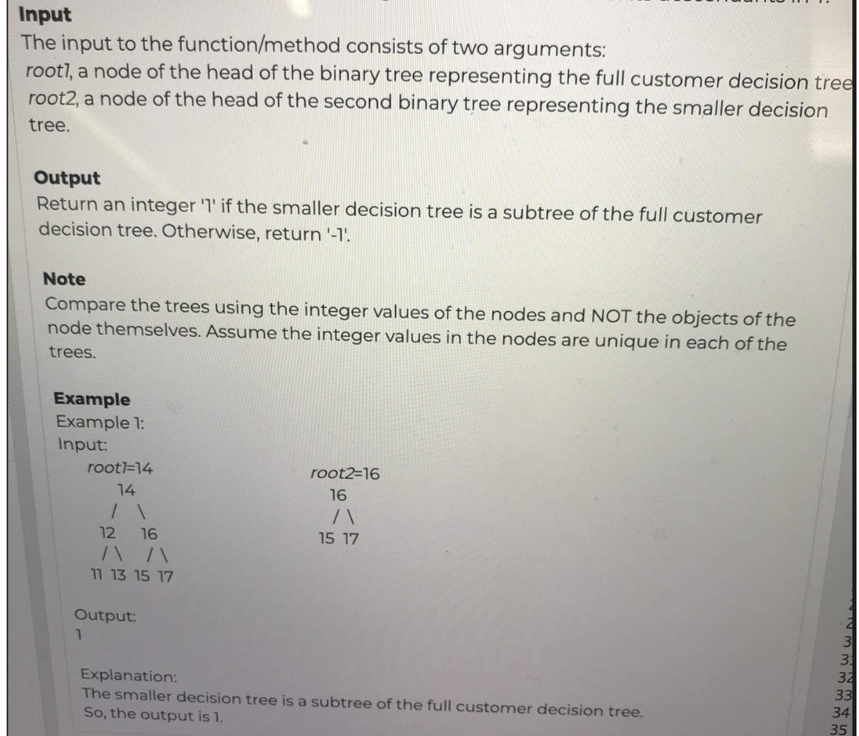

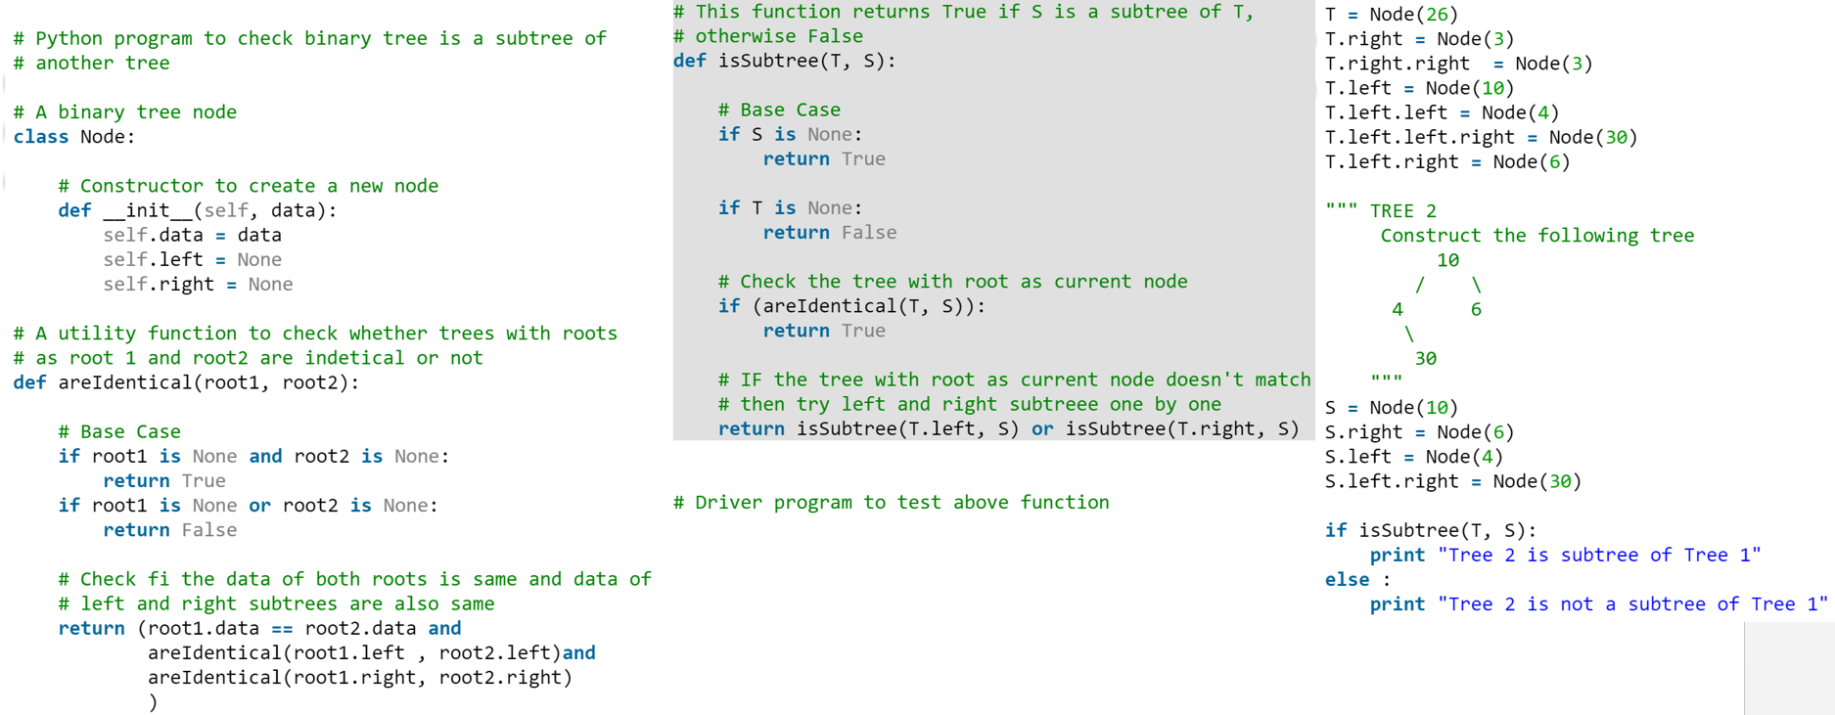

### 8.1.24 Critical connection

<https://leetcode.com/discuss/interview-question/372581>

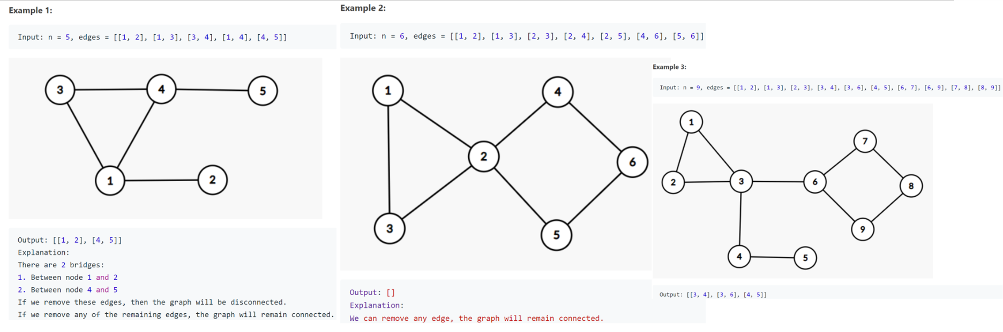

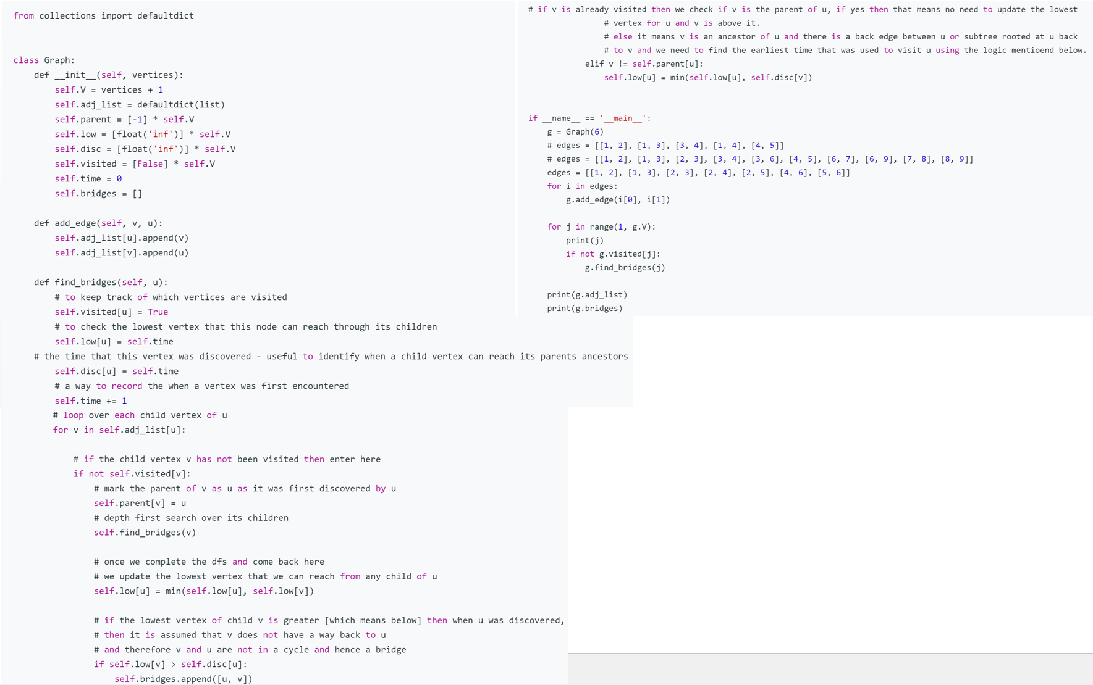

### 8.1.25 . Reverse Linked List II

Reverse a linked list from position *m* to *n*. Do it in one-pass. **Note:**1 ≤ *m* ≤ *n* ≤ length of list.

**Example:**

**Input:** 1->2->3->4->5->NULL, *m* = 2, *n* = 4

**Output:** 1->4->3->2->5->NULL

Method 1:

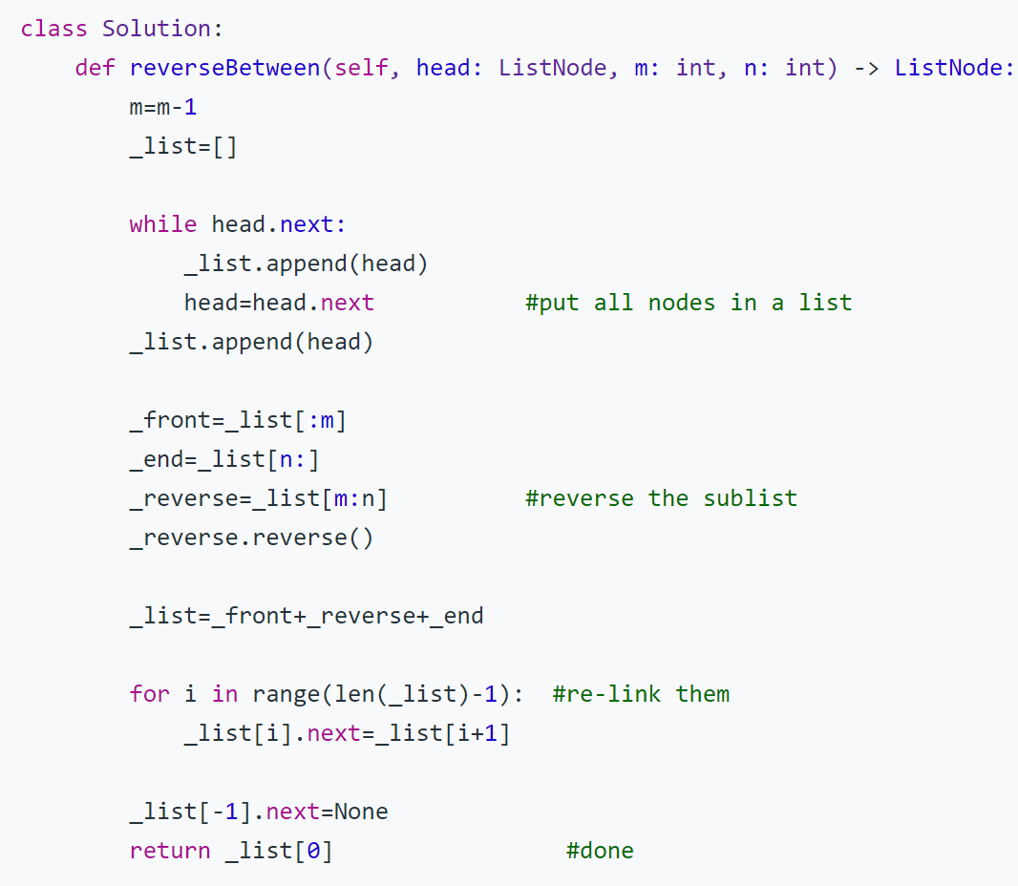

Method 2:

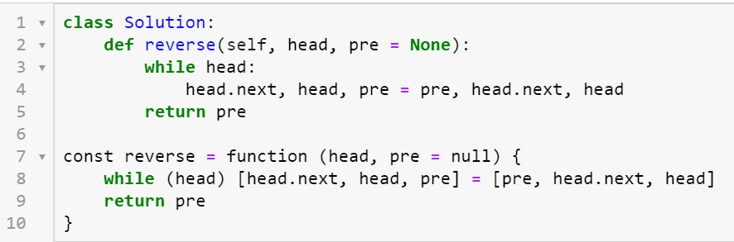

### 8.1.26: Merge two sorted linked lists

e.g:

L1 = 5->10->15, L2 = 2->3->20

Result: 2->3->5->10->15->20

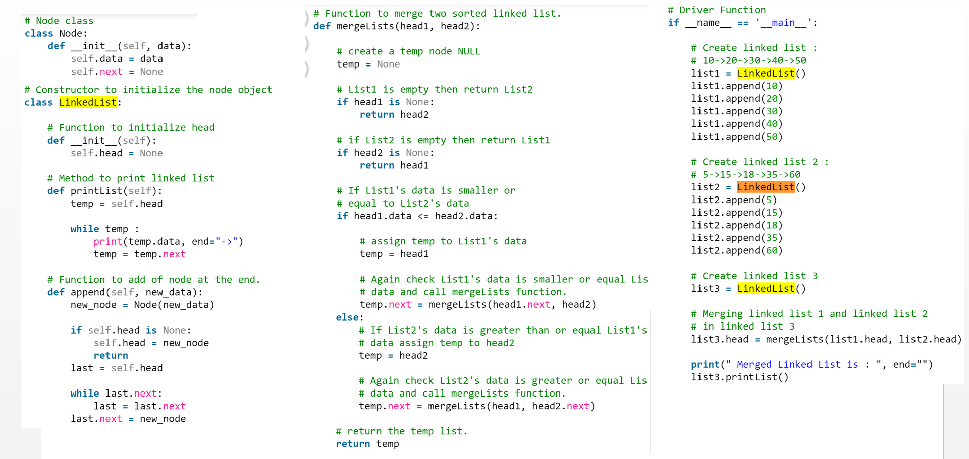

### 8.1.27 right rotation/Rotate String:

We are given two strings, A and B.

A *shift on A* consists of taking string A and moving the leftmost character to the rightmost position. For example, if A = 'abcde', then it will be 'bcdea' after one shift on A. Return True if and only if A can become B after some number of shifts on A.

**Example 1:**

**Input:** A = 'abcde', B = 'cdeab'

**Output:** true

**Example 2:**

**Input:** A = 'abcde', B = 'abced'

**Output:** false

Method 1:

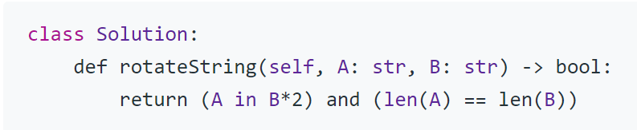

Method 2:

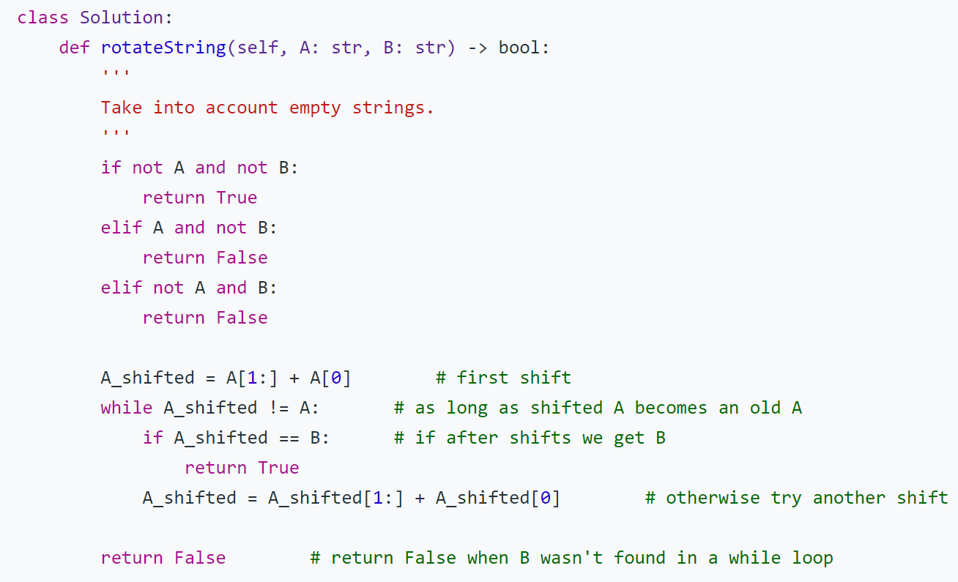

Method 3:

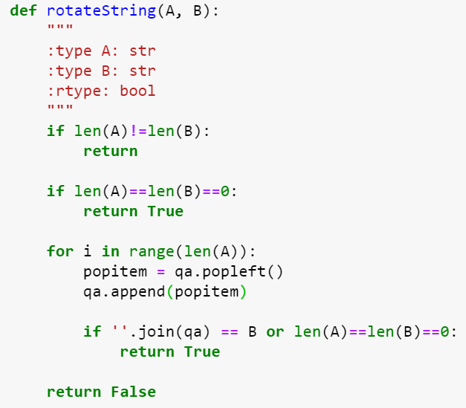

### 8.1.28 Gray Code:

The gray code is a binary numeral system where two successive values differ in only one bit.

Given a non-negative integer *n* representing the total number of bits in the code, print the sequence of gray code. A gray code sequence must begin with 0.

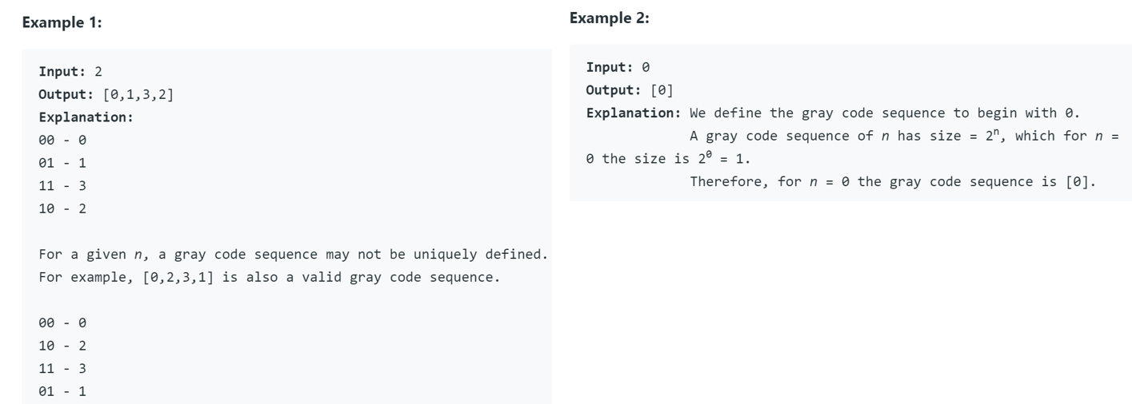

Method 2:

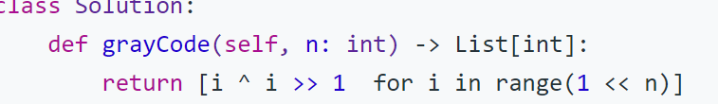

Method 2:

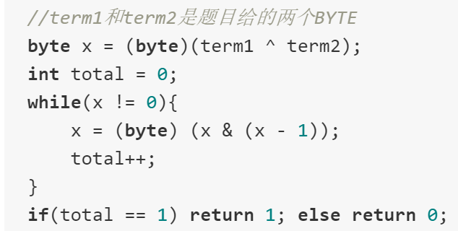

### 8.1.28: remove vowel

**Input :** welcome to geeksforgeeks

**Output :** wlcm t gksfrgks

**Input :** what is your name ?

**Output :** wht s yr nm ?

Method:

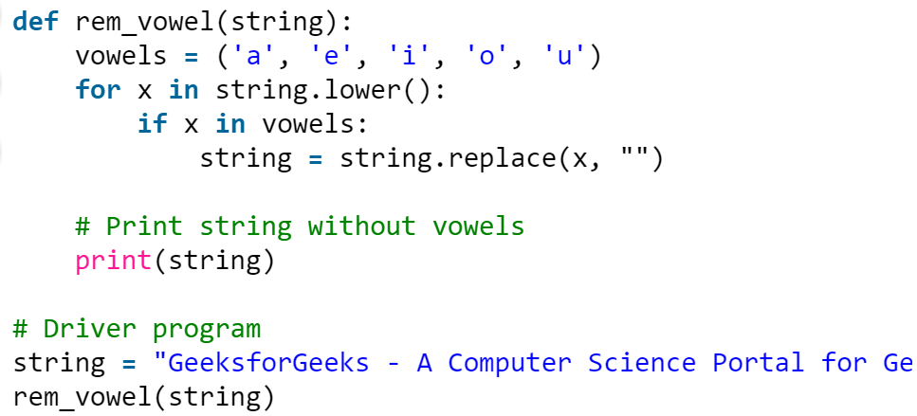

### 8.1.29 high five:

**Description**  
There are two properties in the node student id and scores, to ensure that each student will have at least 5 points, find the average of 5 highest scores for each person.  
  
**Example**  
Input: [[1,91],[1,92],[2,93],[2,99],[2,98],[2,97],[1,60],[1,58],[2,100],[1,61]]

Output:

1: 72.40

2: 97.40

Example 2:

Input: [[1,90],[1,90],[1,90],[1,90],[1,90],[1,90]]

Output: 1: 90.00

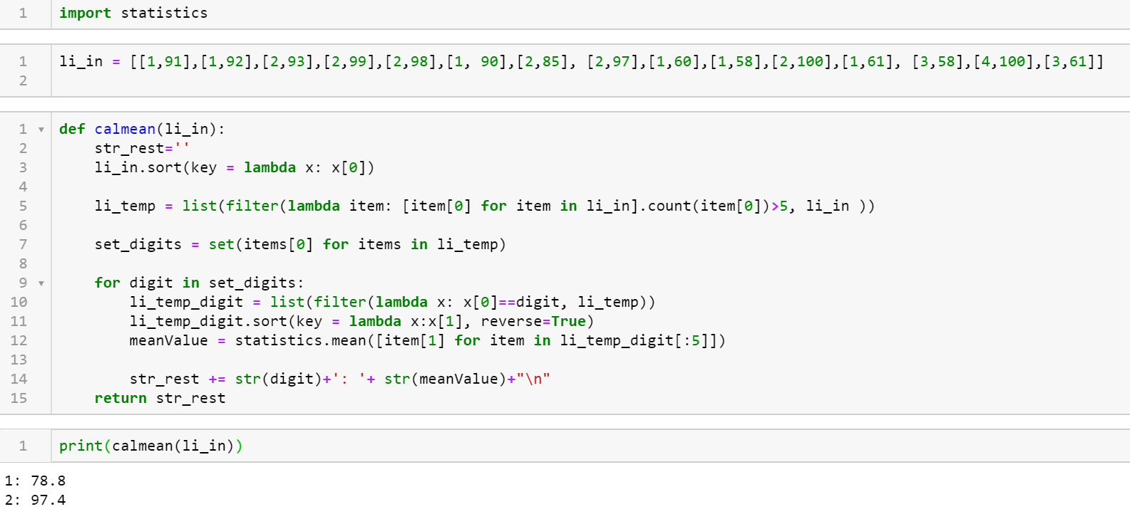

### 8.1.29 Balanced parentheses

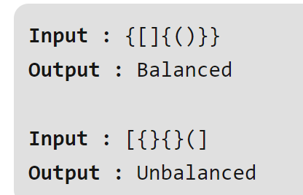

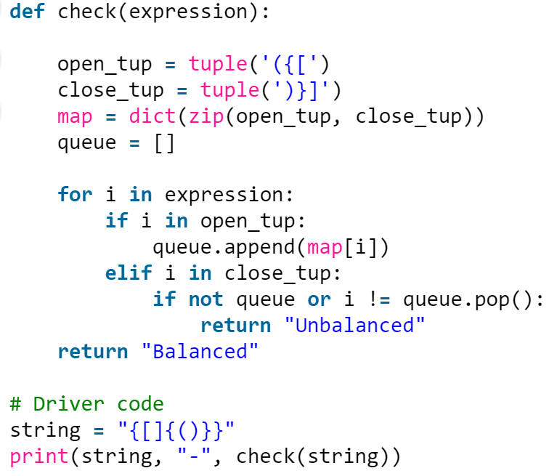

### 8.1.30 Longest Palindromic Substring:

**Example 1:**

**Input:** "babad"

**Output:** "bab"

**Note:** "aba" is also a valid answer.

**Example 2:**

**Input:** "cbbd"

**Output:** "bb"

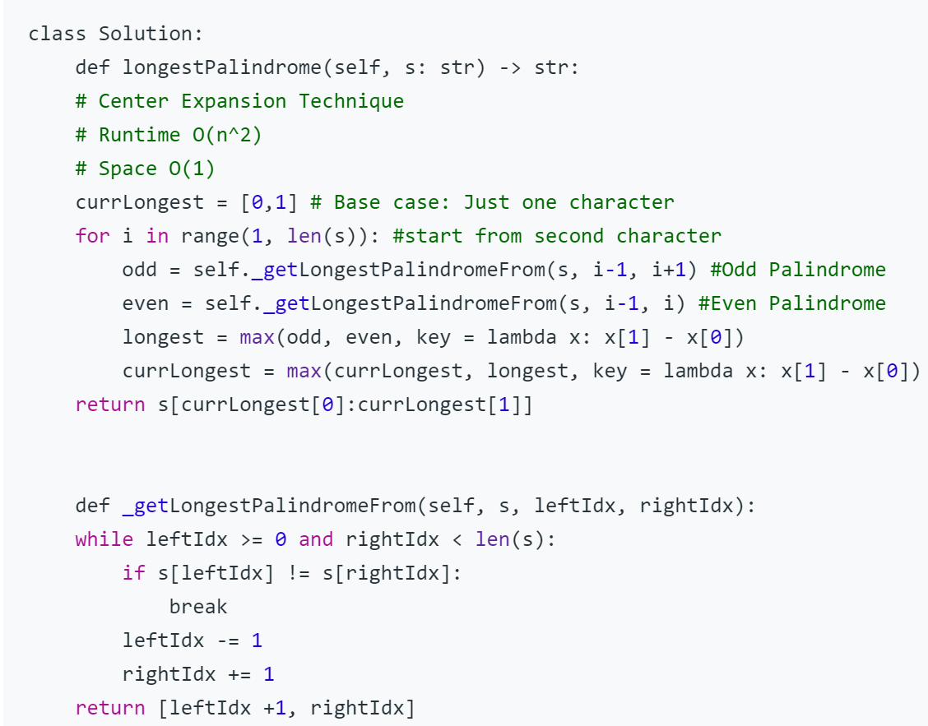

### 8.1.31: [Reverse right half of a linked list](https://stackoverflow.com/questions/39781864/reverse-right-half-of-a-linked-list)

example:

even number: 2->1->3->4->5->6->7->8 =====> 2->1->3->4->8->7->6->5

odd number: 5->7->8->6->3->4->2 ======> 5->7->8->2->4->3->6, the middle one also need be reversed

### 8.1.32: Rectangle Overlap

A rectangle is represented as a list [x1, y1, x2, y2], where (x1, y1) are the coordinates of its bottom-left corner, and (x2, y2) are the coordinates of its top-right corner.

**Example 1:**

**Input:** rec1 = [0,0,2,2], rec2 = [1,1,3,3]

**Output:** true

**Example 2:**

**Input:** rec1 = [0,0,1,1], rec2 = [1,0,2,1]

**Output:** false

<https://leetcode.com/problems/rectangle-overlap/>

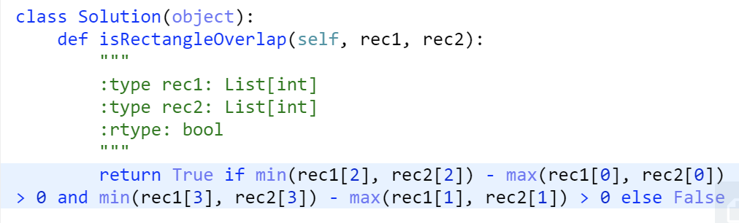

### 8.1.32: LRU loss count

<https://leetcode.com/problems/lru-cache/>

**Input Format:** LRU:最近最少使用(Least Recently Used).替换上次使用距离当前最远的页。The first line contains the cache size S and the number of page requests N separated by a space. The second line containing the N pages being requested from the cache.

**Output Format:** The first line contains the miss count M.

**Example Input/Output 1:**

**Input:**

3 16

7 0 1 2 0 3 0 4 2 3 0 3 2 1 2 0

**Output:**

11

**Example Input/Output 2:**

**Input:**

2 9

2 3 1 3 2 1 4 3 2

**Output:**

8

